Original Instructions
Rebelia Robotic Hand

Contents of the Document
Index
1. Contents of the Document 2
1.1 Method of Consultation 4
2. Health and Safety 5
2.1 Warnings Related to Dangerous Situations 5
2.1.1 Meaning of Symbols 5
2.1.2 Maintenance 7
2.1.3 Normal Functioning 7
2.1.3.1 People near the Gripper 7
2.1.3.2 Gripper holding an object 7
2.1.3.3 Interaction with people 8
2.2 Personal Protective Equipment 8
2.2.1 Protective Tools for Assembly and Maintenance 8
3. Assembly, Installation and Put in Service 9
3.1 Assembly 9
3.1.1 Servomotors Installation 10
3.1.2 Thumb Base and the Tendons-Barrier Installation 11
3.1.3 Spools Installation 12
3.1.4 Upper Fingers Installation 13
3.1.5 Thumb Installation 13
3.1.6 Tendons Installation 15
3.1.6.1 Safety Informations 15
3.1.6.2 Usage of the Nylon Needle 16
3.1.6.3 Tendons Installation for Index or Middle Finger 17
3.1.6.4 Tendons Installation for the Ring and Little Finger 18
3.1.6.5 Tendon Installation for Thumb 20
3.1.6.6 Tendons Installation on Spools (index, middle, ring and little fingers) 21
3.1.6.7 Tendons Installation on Spools (Thumb) 22
3.1.6.8 Installation of the Nylon Cable Ties 22
3.1.7 Installation of the Hand Palm 23
3.1.8 Electronic Card Installation on the Frontal Cover 24
3.1.9 Installation of the Finger Covers 25
3.1.10 Installation of the Gripper covers 26
TO DO: Add a photo of the view after assembly 26
3.2 Installation of the Gripper on Robot Manipulator 26
4. Manufacturer Original Settings of the Equipment 27
5. Performance / Functioning 28
5.1 Start Up 28
5.2 Selecting Control Mode 29
5.3 Fingers Movement 30
5.3.1 Grasp Control Mode 30
5.3.2 RAW Mode 31
5.4 Equipment 32
5.4.1 Assembly Tools 32
5.4.2 Maintenance’s Tools 32
5.5 Exceptional Maintenance 33
5.5.1 Fingers Replacement 33
5.5.2 Fingers Removal 33
5.5.3 Fingers Installation 33
5.5.4 Tendons Removal 33
5.5.5 Tendons Installation 34
5.5.6 Replacing the Motors 34
5.5.7 Servomotors Removal 34
5.5.8 Servomotors Installation 34
5.5.9 Nylon Cable Ties Installation 35
5.5.10 Replacing the Gripper cover 35
5.5.11 Gripper cover removal 35
5.5.12 Gripper cover Installation 35
5.5.13 Replacing the Skeleton 36
5.6 Tendons Registration 36
9.8 Cleaning and Sanitising 37
6. Fault Detection / Troubleshooting 38
7. Documents and Drawings 39
7.1 Components 42
7.2 Nomenclature parts 43
7.2.1 Nomenclature servomotors holes thumb 43
7.2.2 Nomenclature servomotors holes upper fingers 44
7.2.3 Nomenclature servomotors slot 45
7.2.4 Nomenclature servomotors holes flange 46
7.2.5 Nomenclature Tendons-Barrier holes 47
7.2.6 Nomenclature slot and holes upper fingers 48
7.2.7 Nomenclature slot and holes Thumb base 49
7.2.8 Nomenclature tendons holes 50
7.2.9 Nomenclature tendons holes thumb 53
7.2.10 Nomenclature spools holes 54
7.2.11 Nomenclature hand palm holes 55
7.2.12 Nomenclature covers 56
7.2.13 Nomenclature electronic board holes 57

Method of Consultation
We encourage readers to read the safety chapter first, as it is the one containing the most critical and important aspect and information.
You can then choose to read other chapters as randomly as you like, each of which can be consulted separately. Each chapter is linked to the others, so you can skip directly to the relevant section.
The final chapter contains illustrations with the names of components and parts, which you will need to consult during the assembly process.

Health and Safety

Warnings Related to Dangerous Situations

Meaning of Symbols
The following section explains the meaning of the symbols used throughout the manual. Please make sure you have grasped the meaning of each relevant symbols to prevent dangerous circumstances.


READ INSTRUCTIONS MANUAL


MANDATORY USE OF THE VISE


MANDATORY USE OF THE PLIERS


DO NOT SPRAY LIQUIDS ON THE GRIPPER



DANGER OF CUTTING FINGERS BY NYLON CABLES


DANGER OF FALLING OBJECT FROM ABOVE


DANGER OF FLYING OBJECT


DANGER OF FIRE


DANGER OF HOT SURFACES


DANGER OF CUTTING BODY PARTS


DANGER OF CRUSHING BODY PARTS



DANGER OF HARMFUL SUBSTANCES



DANGER HIGH VOLTAGE ELECTRICITY

Maintenance

!! DO NOT PULL TENDONS WITH YOUR BARE HANDS !!

MANDATORY
- Use the vise to hold still the part to be worked on
- Use the pliers to pull the tendons
POSSIBLE INJURIES:
- Severe cuts to fingers
- Severe bleeding requiring immediate surgery

Normal Functioning

People near the Gripper

ATTENTION: the gripper could break while using the machinery!
POSSIBLE INJURIES: If the gripper breaks, some broken parts may be sharp or pointed and could cut people's skin and cause permanent injuries or bleeding and/or require immediate surgery.

Gripper holding an object

ATTENTION: An object could break away from the gripper and hit a person.
POSSIBLE INJURIES: A thrown object could cause: broken bones, cutting or piercing, or burns if it’s very hot, or contamination if it contains or is made from harmful substances.

Interaction with people

ATTENTION: Fingers or human skin can get caught in the machinery mechanisms and get severely injured.
POSSIBLE INJURIES: A finger can be crushed, causing severe bruising to the skin or nails. A nylon tendon can cut a hand finger, causing bleeding where immediate surgery is required. Sharp edges can cut the skin, causing bleeding or bruising.

Personal Protective Equipment

Protective Tools for Assembly and Maintenance

During assemblage and maintenance is mandatory to use the following tools:
- Pliers to hold and pull the tendons
- Vise to hold still the gripper during operation

Assembly, Installation and Put in Service
These instructions explain how to assemble the gripper starting from its already manufactured components.

Assembly
The names of the holes and other parts are defined in the chapter Nomenclature of Parts.
The assemblage consists taking the hand’s skeleton and to install on it all the components following a precise sequence.
IMPORTANT: If the sequence is not followed correctly, all components already installed will have to be dismantled till the moment the sequence was modified, in order to resume again the proper order of the sequence because there are parts that cannot be assembled after others.

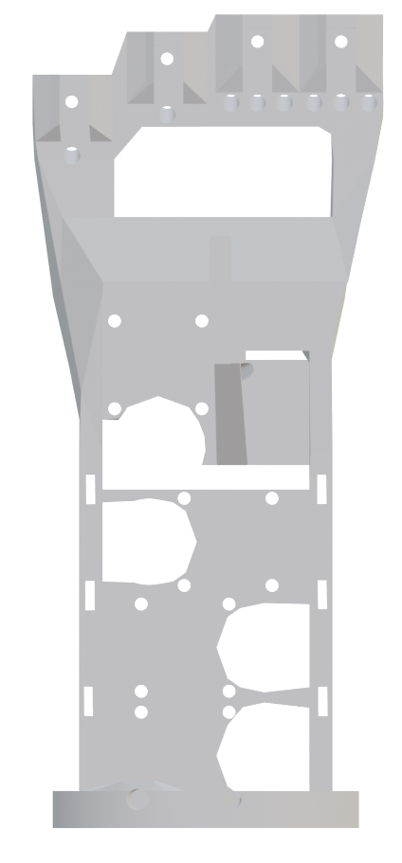Figure 1: Left Hand – Skeleton – Rear View
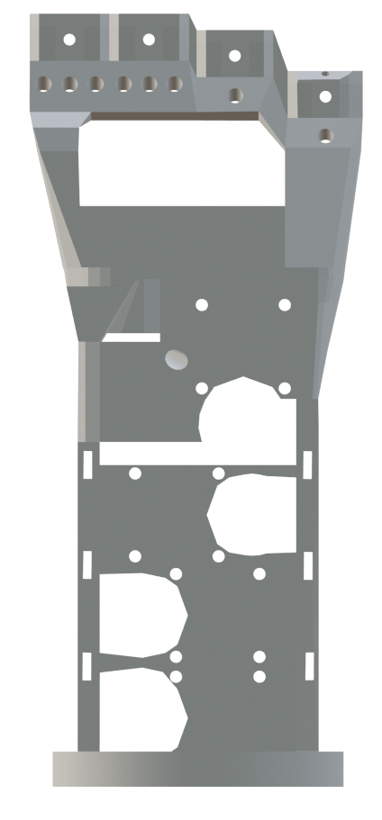Figure 2: Left Hand – Skeleton – Front View

Servomotors Installation
Refer to Chapters: Nomenclature Servomotors Holes Thumb and
Nomenclature Servomotors Holes Upper Fingers

Note: each servomotors must be secured in its slot using 4 screws M2, 8mm long. TBD

1. Install the Thumb Rotation Servomotor in the SSTR slot (Holes: MTR1, MTR, MTR3, MTR4)
◦ Note: Position the motor with the flange facing down.
2. Install the Thumb Flexion Servomotor in the SST slot (Holes: MTF1, MTF2, MTF3, MTF4)
◦ Note: Position the motor with the flange facing the front side of the skeleton.
3. Connect the servomotor in the SSTR slot to the one in the SST slot.
4. Install the Middle Flexion Servomotor in the SSM slot (Holes: MM1, MM2, MM3, MM4)
◦ Note: Position the motor with the flange facing the rear side of the skeleton.
5. Connect the servo motor in the SST slot. to the one in the SSM slot
6. Install the Ring Flexion Servomotor in the SSR slot (Holes: MR1, MR2, MR3, MR4)
◦ Note: Position the motor with the flange toward the rear side of the skeleton
7. Connect the servomotor in the SSM slot to the one in the SSR slot
8. Install the Index Flexion Servomotor in the SSI slot (Holes: MI1, MI2, MI3, MI4)
◦ Note: Position the motor with the flange toward the rear side of the skeleton
9. Connect the servomotor in the SSR slot to the one in the SSI slot
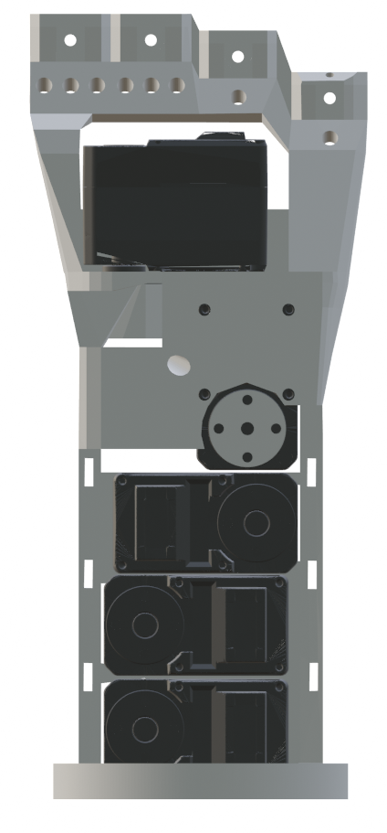Figure 4: Left Hand – Servomotors Built-in – Front View
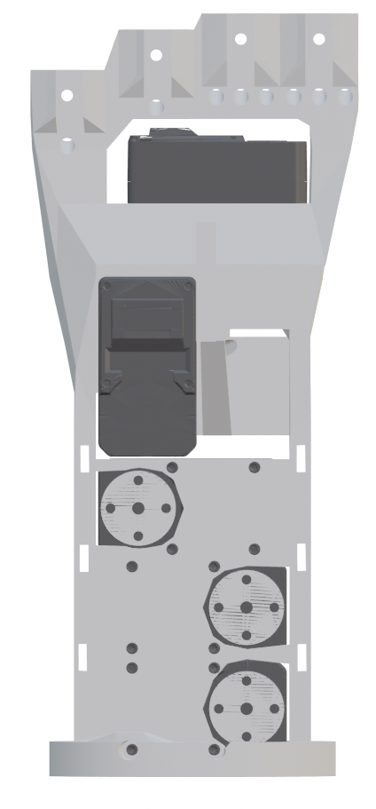Figure 3: Left Hand – Servomotors Built-in – Rear View

Thumb Base and the Tendons-Barrier Installation
Refer to Chapters: Nomenclature Servomotor Holes Flange; Nomenclature Holes Tendons-Barrier and Nomenclature Slot and Holes Thumb Base

1. Thumb Base on Thumb Rotation servomotor flange (4 bolts M3, 10mm long)
* (Flange holes: SF1, SF2, SF3, SF4, Thumb Base holes: BT1, BT2, BT3, BT4)
2. Tendons-Barrier on the rear part of the skeleton (4 screws M2, 8mm long)
* (Holes: TB1, TB2, TB3, TB4)

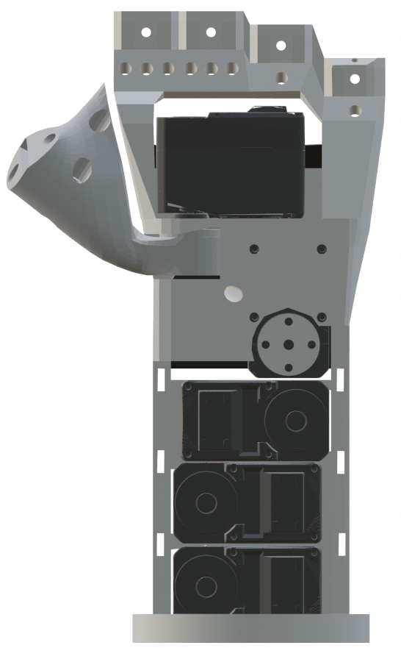Figure 6: Left Hand – Thumb Base Built-in – Front View
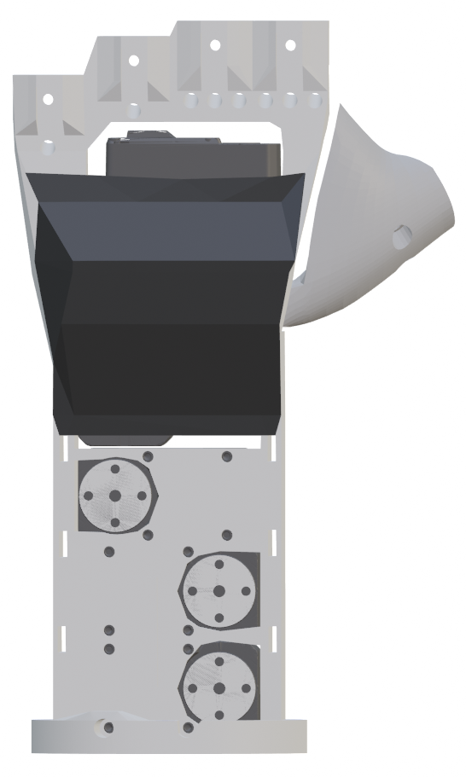Figure 5: Left Hand – Thumb Base Built-in – Rear View

Spools Installation
Refer to Chapters: Nomenclature Servomotor Holes Flange, Nomenclature Holes Spools and Nomenclature Servomotors Slot

1. Place a spool on the servomotor in the SST slot.
2. Screw a spool with four hexagonal head bolts M3, 10mm long, (including a split washer).
3. Place a spool on the servomotor in the SSR slot.
4. Screw a spool with four hexagonal head bolts M3, 10mm long, (including a split washer).
5. Place a winder on the servomotor in the SSI slot.
6. Screw a spool with four hexagonal head bolts M3, 10mm long, (including a split washer).
7. Place a winder on the servomotor in the SSM slot.
8. Screw a spool with four hexagonal head bolts M3, 10mm long, (including a split washer).

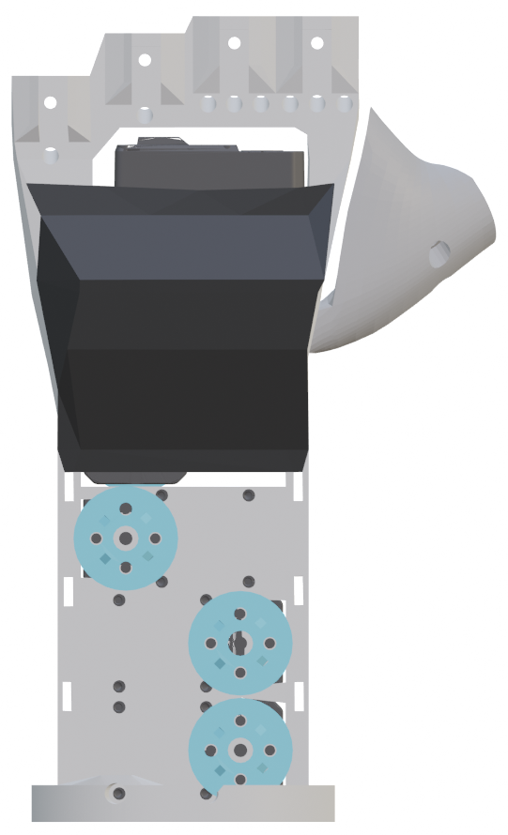Figure 7: Left Hand – Spools and Tendons-Barrier Built-in – Front View
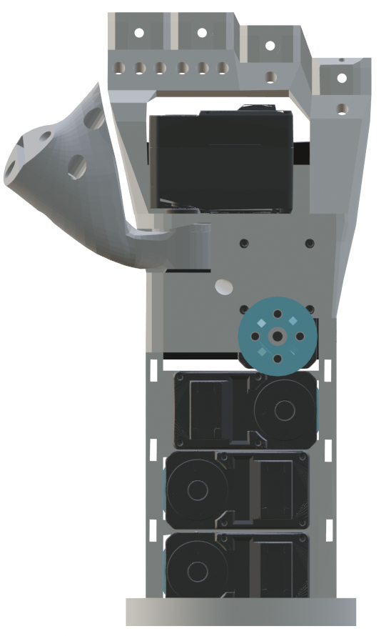Figure 8: Left Hand – Spools and Tendons-Barrier Built-in – Rear View

Upper Fingers Installation
Refer to Chapter: Nomenclature Slot and Holes Upper Fingers

Note: Each finger must be secured in its slot on the skeleton with a bolt M3 and long 10mm.
Insert the finger into the slot, then the bolt from behind, then the nut on the front of the skeleton and bolt it.
Assembly sequence:
1. Index (slot: SI; holes: BI1, BI2)
2. Middle (slot: SM; holes: BM1, BM2)
3. Ring (slot: SR; holes: BR1, BR2)
4. Little (slot: SL; holes: BL1, BL2)

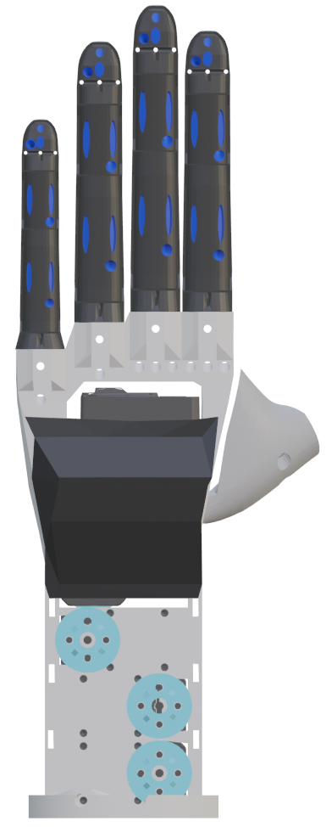Figure 10: Left Hand – Upper Fingers Built-in – Front View
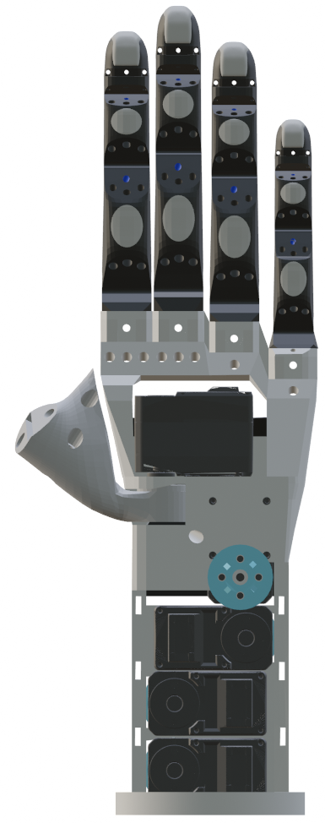Figure 9: Left Hand – Upper Fingers Built-in – Rear View

Thumb Installation
Refer to Chapter: Nomenclature Slot and Holes Thumb Base

Note: The thumb must be secured in its ST slot on the thumb base with 2 bolts M3, long 15mm. TBD

Insert the thumb into the slot, then the 2 bolts from behind (holes BT5, BT6), then the nuts from the other side (holes: BT7, BT8), and bolt it.
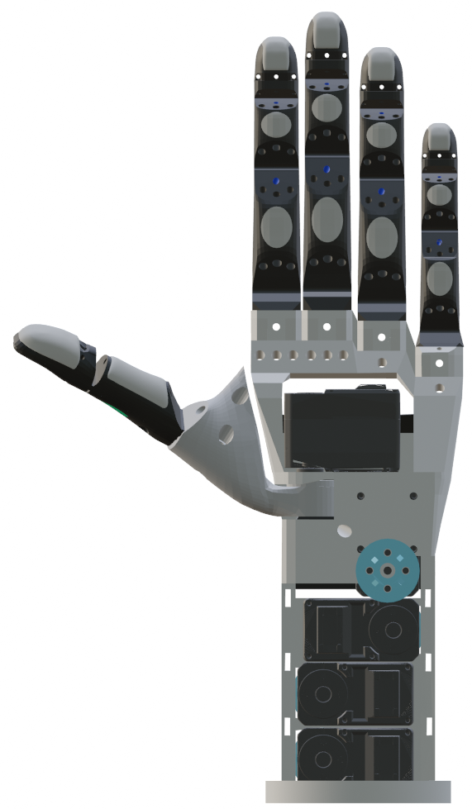Figure 11: Left Hand – Thumb Built-in - Front View

Tendons Installation

Safety Informations

!! DO NOT PULL TENDONS WITH BARE HANDS!!
MANDATORY
- Use the vise to hold still the part to be worked on
- Use the pliers to pull the tendons
POSSIBLE INJURIES:
- Severe cuts to fingers
- Severe bleeding

MANDATORY TO USE THE VISE

MANDATORY TO USE THE PLIERS

DANGER OF CUTTING FINGERS BY NYLON CABLES

Usage of the Nylon Needle
Tendons are thin and difficult to thread, so a special needle is needed. This special needle is actually a nylon thread used as a needle. This method was chosen after multiple attempts, using various tools, as it proved to be the fastest, most reliable, and safest.
The following shows the procedure for threading the tendon through a hole using a nylon thread
(10cm, 0.35mm diameter) as a needle:

ATTENTION: Tendons can cause severe cuts to fingers!
MANDATORY: Use the vise to hold still the spools and use the pliers to pull the tendons.

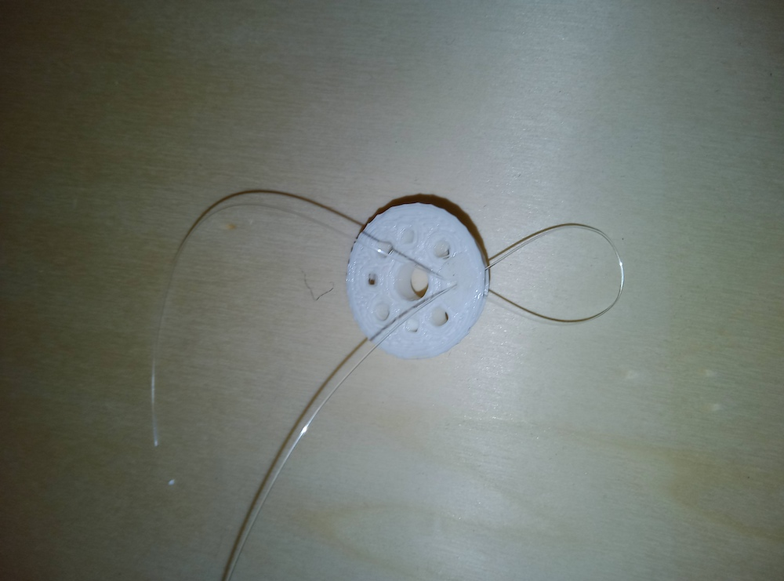Figure 12: One at the time insert ends of the nylon thread in the hole.
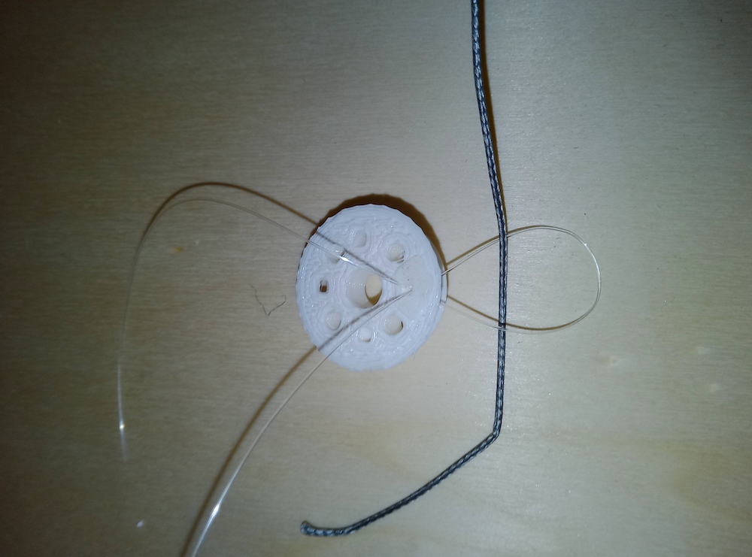Figure 13: Insert tendon into the nylon thread loop

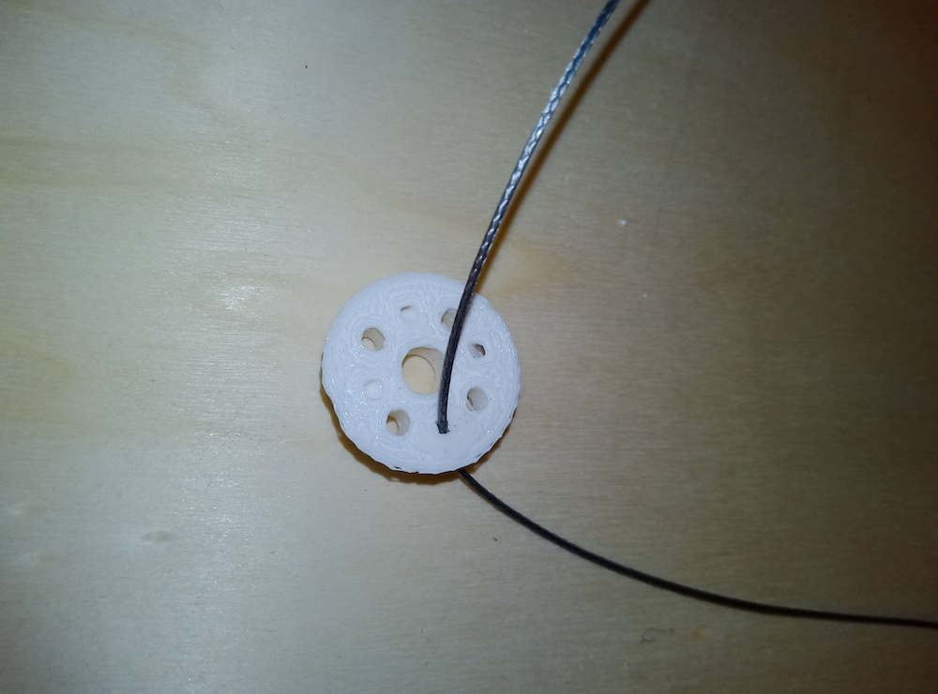Figure 14: Pull with the pliers the shorter part of the tendon onto the other side of the hole

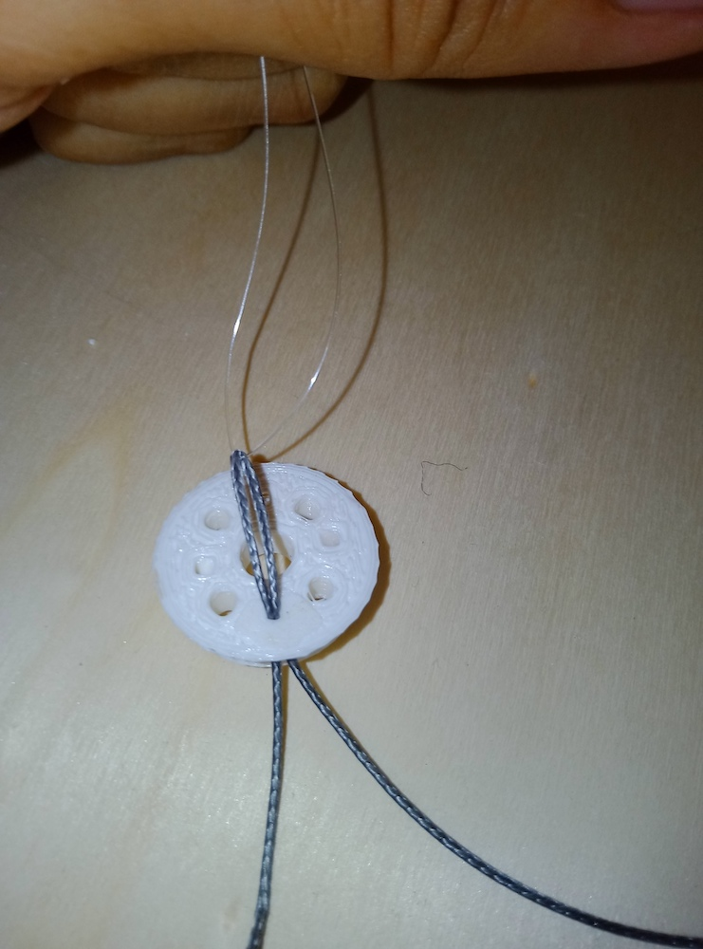Figure 15: Using the pliers, pull the two ends of the nylon loop onto the other side of the hole

NOTE: From now on, we will simply refer to this sequence of operations as "Threading the
Tendon". It is implicitly assumed that this is done using the nylon needle.

Tendons Installation for Index or Middle Finger

ATTENTION: Tendons can cause severe cuts to fingers!
MANDATORY: Use the vise to hold still the skeleton and the pliers to pull the tendon.

Refer to Chapters: Nomenclature Holes Tendons and Nomenclature Servomotors Slot
The same procedure also applies to the Middle Finger Tendon Installation

1. At the back of the skeleton,
insert the tendon into the hole HI1
2. On the front of the skeleton:
• pull it out from the hole HI4
• insert it in the hole HI5 from below and pull out from above
• insert it in the hole HI6 and pull it out from the hole HI7
• insert it in the hole HI8 and pull it out from the hole HI9
• insert it in the hole HI10 and pull it out from the hole HI11
• insert it in the hole HI12
3. At the back of the skeleton:
• pull it out from the hole HI14
• insert it in the hole HI15
4. On the front of the skeleton:
• pull it out from the hole HI13
IMPORTANT: Roll the tendon twice around the part of the tendon coming out from the hole HI11 and going in the hole HI12
NOTE: Make sure the tendon is securely attached to the distal phalanx of the finger and cannot be snatched off by pulling it with the pliers.
• insert it into hole HI14.
5. At the back of the skeleton:
• using the pliers pull the tendon out from the hole H16 until it is securely fixed (the motor winding made in the previous step should reduce due to the narrowing of the coils.
• insert it into the hole HI17 and pull it out through the hole HI18.
• insert it into the hole HI19 and pull it out through the hole HI20.
• insert it into the hole HI21 and pull it out through the hole HI22.
• insert it into the hole HI23 and pull it out through the hole HI24.
• insert it into the hole HI2 from the top and pull out from below.
• tendon must pass over the tendon barrier.
• tendon must pass under the nylon ties (if already installed) until it reaches the roll at the slot SSI

Tendons Installation for the Ring and Little Finger

ATTENTION: Tendons can cause severe cuts to fingers!
MANDATORY: Use the vise to hold still the skeleton and the pliers to pull the tendon.

Refer to Chapter: Nomenclature Tendons Holes and Nomenclature Servomotors Slot

NOTE: The Ring and Little Finger differ in their installation procedures from the other fingers, since they are inter-dependent and share part of the same tendons.

1. At the back of the skeleton
• insert one end of the tendon into the hole HR1 and pull it out of the hole
• insert the other end of the tendon into the hole HL1
2. On the front of the skeleton
• pull out one end of the thread from the hole HR4
• pull out the other end from the hole HL4
3. At the back of the skeleton
• Make sure that 3cm length of tendon are spared (TBD) at the back of the skeleton
(ALL FIGURES)
4. On the front of the skeleton
a) Take the end of the tendon coming out of the hole HR4
• insert it into the hole HR5 from below and pull it out from the top
• insert it into the hole HR6 and pull it out from the hole HR7
• insert it into the hole HR8 and pull it out from the hole HR9
• insert it into the hole HR10 and pull it out from the hole HR11
• insert it into the hole HR12
b) At the back of the skeleton:
• Pull the tendon out of the hole HR14
• Insert it into the hole HR15
c) On the front of the skeleton:
• Pull the tendon out of the hole HR13
IMPORTANT: Roll the tendon twice around the part of the tendon coming out from the hole HR11
and going in the hole HR12
NOTE: Make sure that the tendon, when stretched with the pliers, is securely fixed to the distal phalanx of the finger and cannot slip out.
• insert it into the hole HR14
5. At the back of the skeleton
• using the pliers, pull the tendon out from the hole HR6 until it is well secured (the motor winding made in the previous step will reduce due to the narrowing of the coils).
• insert it into the hole HR17 and pull it out from the hole HR18
• insert it into the hole HR19 and pull it out from the hole HR20
• insert it into the hole HR21 and pull it out from the hole HR22
• insert it into the hole HR23 and pull it out from the hole HR24
• insert it into the hole HR2 from above and pull it out from below

6. On the front of the skeleton
a) Take the end of the tendon coming out of the hole HL4
• insert it into the hole HL5 from below and pull it out from the top
• insert it into the hole HL6 and pull it out from the hole HL7
• insert it into the hole HL8 and pull it out from the hole HL9
• insert it into the hole HL10 and pull it out from the hole HL11
• insert it into the hole HL12
b) At the back of the skeleton:
• pull the tendon out of the hole HL14
• insert it into the hole HL15
c) On the front of the skeleton:
• pull the tendon out of the hole HL13
IMPORTANT: Roll the tendon twice around the part of the tendon coming out from the hole HL11
and going into the hole HL12
NOTE: Make sure that the tendon, when stretched with the pliers, is securely fixed to the distal phalanx of the finger and cannot slip out.
• insert it into the hole HL14
7. At the back of the skeleton
• using the pliers, pull the tendon out from the hole HR6 until it is well secured (the motor winding made in the previous step will reduce due to the narrowing of the coils).
• insert it into the hole HL17 and pull it out from the hole HL18
• insert it into the hole HL19 and pull it out from the hole HL20
• insert it into the hole HL21 and pull it out from the hole HL22
• insert it into the hole HL23 and pull it out from the hole HL24
• insert it into the hole HL2 from above and pull it out from below
8. At the back of the skeleton
• take the end of the tendon coming out of the hole HR2 and insert it into a tendon clamp
• take the end of the tendon coming out of the hole HL2 and insert it into the same tendon clamp on
the opposite/other side
PROCEDURE of PRECISION (A)
• make sure the tendon segment between the hole HR2 hole and the tendon clamp is 5cm of length (TBD).
• make sure the tendon segment between the hole HL2 hole and the tendon clamp is 4.5cm of length (TBD).
• Crimp the clamp with the appropriate crimping tool without modifying the segments in the previous steps.
PROCEDURE of PRECISION (B)
• take a new tendon and make a loop around the tendon of the left-hand side of the clamp in the preceding/previous step
• make sure that the loop has a diameter of 3mm (TBD) so that the other tendon can slide easily inside it
• fasten the loop with a clamp using the crimper
• cut one edge of the loop and leave the other long
• take the longer edge of the loop made with the tendon and make it pass over the tendon barrier
• make it pass under the nylon ties (if already installed) until it reaches the spool at the SSR slot.

Tendon Installation for Thumb

ATTENTION: Tendons can cause severe cuts to fingers!
MANDATORY: Use the vise to hold still the skeleton and the pliers to pull the tendon.

Refer to Chapter: Nomenclature Tendons Holes Thumb and Nomenclature Servomotors Slot

1. On the front of the Thumb
• insert tendon into the hole HT1 and pull it out through the hole HT2
• insert it into the hole HT3 from below and pull it out from above
• insert it into the hole HT4
2. At the back of the Thumb
• pull it out through the hole HT7
• insert it into the hole HT8
3. On the front of the Thumb
• pull it out through the hole HT5
IMPORTANT: Roll the tendon twice around the part of the tendon coming out from the hole HT3 and going into the hole HT4 (TO DO: photo for clarity)
NOTE: Make sure that the tendon, when stretched with the pliers, is securely fixed to the distal phalanx of the finger and cannot slip out.
• insert it into the hole HT6
4. At the back side of the Thumb
• pull it out through the hole HT9
• insert it into the hole HT10 and pull it out through the hole HT11
5. Take the end of the tendon coming out of the hole HT1
6. Insert it into the hole HT12 in the base of the thumb and pull it out of the hole HT14
7. Take the end of the tendon coming out of the hole HT11
8. Insert it into the hole HT13 in the base of the thumb and pull it out of the hole HT14

Tendons Installation on Spools (index, middle, ring and little fingers)

ATTENTION: Tendons can cause severe cuts to fingers!
MANDATORY: Use the vise to hold still the skeleton and the pliers to pull the tendon.

Refer to Chapter: Nomenclature Holes Spools

1. Connect the Servomotor to the SSI slot on the electronic board.

2. Power the electronic board with a 12V DC power supply capable of delivering up to 14A, with a single-pole connector having a central positive hole.

3. Connect via Bluetooth to the electronic board (name: “ESP32”)

4. Send via Bluetooth the serial command selecting 'Tendons Installation Mode'.

5. Wait for the Servomotors to complete their movement and proceed to the next step.

6. For each finger:
a) Extension Tendon
• Turn it of almost one full turn clockwise (TBD) around the spool and then insert it into the spool’s hole HS4.
• Pull the tendon with the pliers until the finger is in its maximum opening position.
• While holding the tendon pulled with the pliers, turn it anticlockwise around the bolt at the hole BS4.
• Keeping the tendon pulled with the pliers, screw the bolt of the hole BS4 until the tendon is locked underneath the bolt.
b) Flexion Tendon
• Turn it of almost half turn anticlockwise (TBD) around the spool and then insert it into the spool’s hole HS2.
• Pull the tendon with the pliers until the finger is in its maximum opening position.
• While holding the tendon pulled with the pliers, turn it anticlockwise around the bolt at the hole BS2.
• Keeping the tendon pulled with the pliers, screw the bolt of the hole BS2 until the tendon is locked underneath the bolt.

Tendons Installation on Spools (Thumb)

ATTENTION: Tendons can cause severe cuts to fingers!
MANDATORY: Use the vise to hold still the skeleton and the pliers to pull the tendon.

TO DO

Installation of the Nylon Cable Ties

TO DO

Installation of the Hand Palm
Place the Palm on the hand and fix it with 4 screws M2,10mm long.

TO DO ADD Photos for clarity (Holes of Skeleton):

Electronic Card Installation on the Frontal Cover
Place the electronic board into the slot of the front cover, screw it with 4 screws M2, 6mm long.

TO DO: Add illustration with holes on the front cover

Installation of the Finger Covers
For each Upper Finger (index, middle, ring, and little finger):
1. Place the distal cover on the distal phalanges and press to lock it in place.

2. Place the medial cover on the medial phalanges and press to lock it in place.

3. Place the proximal cover on the proximal phalanges and press to lock it in place.

For the Thumb:
1. Place the distal cover on the distal phalanges and press to lock it in place.

2. Place the proximal cover on the proximal phalanges and press to lock it in place.

TO DO: Add a photo of the view after assembly

Installation of the Gripper covers
1. Make sure that the electronic board is already been built-in in the front cover.

2. Connect with a cable the Servomotor in the SSM slot to the electronic board.

3. Place the front cover, which includes the electronic board already plugged in, on the front part of the skeleton and press to lock it in place.

4. Place the back cover, which includes the electronic board already plugged in, on the rear part of the skeleton and press to lock it in place.

TO DO: Add a photo of the view after assembly

Installation of the Gripper on Robot Manipulator
1. Place the flange on the robot wrist and align it with the alignment pin.

2. Bolt with 4 countersunk head bolts M6, 3cm long (TBD)

3. Place the gripper on the flange according to the desired orientation.

4. Bolt with 4 countersunk head bolts M3, 3cm long (TBD)

5. Plug in the gripper's power cable to the robot wrist connector.

NOTE: The power supply must be set to 12V DC.

USE ONLY POWER SUPPLY WITH THE FOLLOWING OUTPUT FEATURES:
VOLTAGE: 12V DC
CURRENT: 14A
POWER: 170 W

TO DO: Add Photos

Manufacturer Original Settings of the Equipment
The gripper's default settings are as follows:
• Control Mode
• Grasp Control

MONKEY GRASP:
• Finger Position:
• Factor: 0% (maximum opening)
• Bluetooth Device Name: TBD (ESP32)

Performance / Functioning

READ THE INSTRUCTION MANUAL BEFORE USING THE GRIPPER



READ THE INFORMATION REGARDING THE NORMAL FUNCTIONING

Start Up
To start the gripper, activate the power supply from the controller on the robotic arm upon which it’s installed, so that the robot wrist connector supplies 12V and at least 162W of power.

The gripper begins the self-calibration phase of the tendons; once this phase is completed, the gripper will be in its maximum opening position, in the grasping mode: monkey grasp.

Connect to the gripper from the robot control system, via a Bluetooth serial connection (BT device name: “ESP32”)
Serial commands are in the format #CMD##\r\n, where CMD is the command string.

Examples:
• Command: #MONKEY##\r\n\
• The command string is: “MONKEY”
• Command: #I%dM%dR%dT%dTR%d ##\r\n
• The command string is: “I%dM%dR%dT%dTR%d

Selecting Control Mode
Control Mode | Final Command
Monkey grasp | #MONKEY##\r\n
Power grasp | #POWER##\r\n
PowerSmall grasp | #POWERSMALL##\r\n
Pinch grasp | #PINCH##\r\n
Relax | #RELAX##\r\n
RAW | #RAW##\r\n

Fingers Movement

Grasp Control Mode
If it is selected one of these modes: MONKEY, POWER, POWER-SMALL, PINCH, the gripper can be controlled as follows:
- Command: #%d##\r\n
- Meaning:
- %d express the integer value [0, 100] expressing the percentage of fingers’ closure (each type of selected grasp applies the closure to all fingers differently than the other grasps)

Examples:

EXAMPLE | FINAL COMMAND
MAXIMUM OPENING | #0##\r\n
MAXIMUM CLOSURE | #100##\r\n
CLOSURE 50% | #50##\r\n
CLOSURE 75% | #75##\r\n

RAW Mode
If it is selected a RAW mode, the gripper can be controlled as follows:
- Command: #I%dM%dR%dT%dTR%d##\r\n
- Meaning:
◦ I %d: the value %d contains an integer with the value closure [0, 100] index flexion
◦ M %d: the value %d contains an integer with the value closure [0, 100] middle flexion
◦ R %d: the value %d contains an integer with the value closure [0, 100] ring flexion
◦ T %d: the value %d contains an integer with the value closure [0, 100] thumb flexion
◦ TR %d: the value %d contains an integer with the value closure [0, 100] thumb rotation

Examples:
EXAMPLE | FINAL COMMAND
Index Flexion: 30%  Middle Flexion: 50%  Ring and Little Flexion: 10%  Thumb Flexion: 70%  Thumb Rotation: 65% | #I30M50R10T70TR65##\r\n
Index Flexion: 10%  Middle Flexion: 20%  Ring and Little Flexion: 30%  Thumb Flexion: 40%  Thumb Rotation: 50% | #I10M20R30T40TR50##\r\n
Flexion: maximum opening  Thumb Rotation: maximum opening (open hand) | #I0M0R0T0TR0##\r\n
Flexion: maximum closure  Thumb Rotation: maximum closure (thumb in opposition) | #I0M0R0T0TR100##\r\n

Equipment

Assembly Tools
These are the tools and equipment required for assembly:
DESCRIPTION | QUANTITY | MANUFACTURER | MODEL
Long Phillips screwdriver for electronics | 1 | TBD | TBD
Universal Pliers | 1 | TBD | TBD
Hexagonal Key 2.5mm | 1 | TBD | TBD
Vise | 1 | TBD | TBD
Scissors | 1 | TBD | TBD
Tendon Clamp Crimping Tool | 1 | TBD | TBD

Maintenance’s Tools
These are the tools and equipment required for maintenance:
DESCRIPTION | QUANTITY | MANUFACTURER | MODEL
Universal Pliers | 1 | TBD | TBD
Hexagonal Key 2.5mm | 1 | TBD | TBD
Vise | 1 | TBD | TBD

Exceptional Maintenance
These operations are done only in the case where one component require replacement.

Fingers Replacement
To carry out in sequence:
1. Dis-installation of the Tendon
2. Dis-installation of the Finger
3. Installation of the Finger
4. Installation of the Tendon
5. Adjustment of the Tendon

Fingers Removal

USE THE VISE

1. Unscrew all bolts fixing the fingers
2. Remove all fingers from their slot

Fingers Installation

USE THE VISE

Refer to Chapter #5.1.4. Upper Fingers’ Installation|outline
Refer to Chapter #5.1.5. Thumb’s Installation|outline

Tendons Removal

- Cut all tendons with scissors.
- Unscrew the bolts fixing the tendons from all the spools using the hexagonal key of 2.5mm
- Remove all tendons using the pliers.

Tendons Installation

Refer to Chapter #5.1.6. Tendons Installation|outline

Replacing the Motors
Carry out in sequence:
- Dis-installation of the motors
- Installation of the motors

Servomotors Removal
- Remove each servomotors by unscrewing the 4 screws fixing them, following exclusively this sequence:
1. Flexion Servomotor ring-little fingers
2. Flexion Servomotor index finger
3. Flexion Servomotor middle finger
4. Flexion Servomotor thumb
5. Rotation Servomotor thumb

Servomotors Installation
Refer to Chapter: #5.1.1.Assembly Servomotors|outline

Nylon Cable Ties Installation

Refer to Chapter: Installation of the Nylon Cable Ties

Replacing the Gripper cover
To carry out in sequence:
- Dis-installation of the cover
- Installation of the cover

Gripper cover removal
- Dismantle the snap-on front cover (Hand palm side)
- Dismantle the snap-on back cover (Backside gripper)

Gripper cover Installation
Refer to Chapter: Installation of the gripper covers

Replacing the Skeleton
To replace the skeleton is necessary to dismantle all components and reassemble the gripper from the beginning.
To carry in sequence:
1. Cover Removal
2. Board Removal
3. Tendon Removal
6. Spools Removal
7. Fingers Removal
8. Servomotor Removal
9. Installation of the Servomotor
10. Installation of the Finger
11. Installation of the Spool
12. Installation of the Nylon Cables Tie
13. Installation of the Tendon-Barrier
14. Installation of the Tendon
15. Installation of the Board
16. Installation of the Cover

Tendons Registration
For each finger requiring registration:
- Block the gripper with the Vise
- Connect the servomotor in the SSI slot to the electronic Board.
- Feed electronic board with power supply 12V DC that can deliver up to 14A, with a single-pole connector with a central positive hole
- Connect to electronic board via Bluetooth (device name: TBD)
- Send via Bluetooth serial selection command 'Tendons’ Installation Mode'.
- Wait that servomotors complete their calibration and then proceed to next step
- For each finger requiring registration:
  - Loosen the extension tendon bolt of 2 turns using the 2.5mm hex key
  - Unscrew the flexion tendon bolt of 2 turns using the 2.5mm hex key
  - Make sure that the finger is totally extended, otherwise it is necessary to extend it manually
  - Using the pliers in one hand, take the extension tendon and pull until it is well stretched
  - While holding the tendon pulled with the Pliers, with the other hand screw the fixing bolt till it is very tight TBD
  - Release the tendon with the Pliers.
  - Make sure that the finger is fully extended under the pulling of the tendon.
  - Using the Pliers with one hand, take the flexion tendon and pull until it is well stretched.
  - While holding the tendon pulled with the Pliers, with the other hand screw the fixing bolt till it is very tight TBD
  - Loosen the tendon with the Pliers.

9.8 Cleaning and Sanitising
The external surfaces of the gripper can be cleaned with a cloth lightly moistened with alcohol.
The external surfaces of the gripper can be cleaned with a cloth lightly moistened with Amuchina.

DO NOT SPRAY LIQUIDS ON THE GRIPPER

Fault Detection / Troubleshooting
ANOMALY | CAUSE
- Limp/wobbly fingers even when not powered  - Fingers that close late  - Fingers that don't close completely | - Tendons not stretched (gripper used beyond load limits)
- Fingers that do not open properly | - tendon calibration failed
- Fingers that do not move | - damaged tendons  - detached tendon  - damaged motors  - power outage  - damaged spools
- The motors stop exercising force after a certain time | - Overheating servomotors
- Cannot make a Bluetooth connection with gripper | - Grater distance from controlling device or interference or obstacles
- Fingers that do not grip the object | - Worn Pads
- Damaged or worn parts | - Breakage or wear and tear  - Breakage or wear from improper use

CAUSE | SOLUTION/REMEDY
- Tendons not stretched | - remove the cover and perform the tendon adjustment
- Damaged tendons | - Replace the tendons
- Calibration tendons failed | - Restart the gripper to repeat the self-calibration.  - Turn off the gripper, remove the covers, and check that the tendons are not caught between themselves or with other parts of the gripper.
- Detached tendons | - Turn off the gripper, remove the covers and reattach or replace the tendon, then perform the tendon registration
- Overheating servomotors | - Ensure that the gripper is used within the correct operating range
- Greater distance from the controlling device or interference or obstacles | - Move the controller within Bluetooth range (<9m)  - Remove any obstacles between the controller and the gripper  - Eliminate any interference
- Worn Pads | - Replace the parts containing the damaged pads
- Power blackout | - Check that the power is on and properly connected.  - Check that the power cables are not damaged.
- Breakage or wear and tear  - Breakage or wear from improper use | - Replace damaged parts with new or manufacturer-reconditioned parts

Documents and Drawings
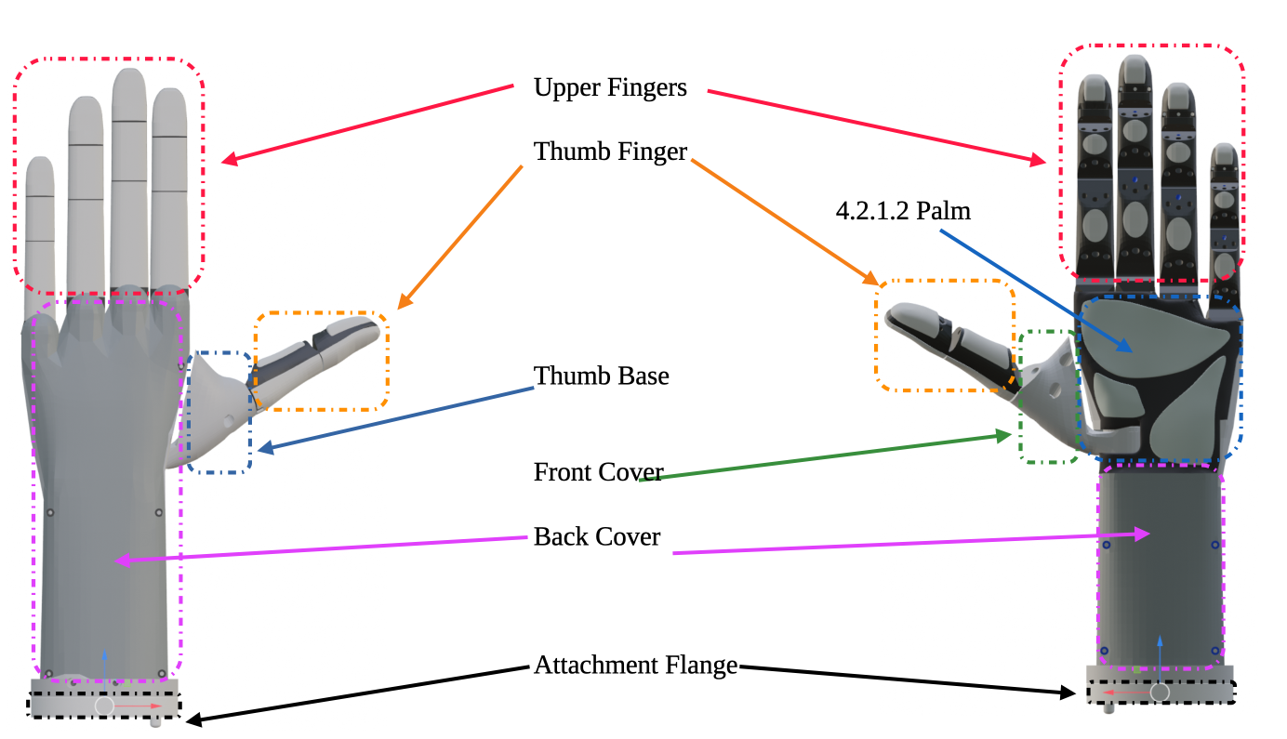Figure 16: General drawing - left hand - external view
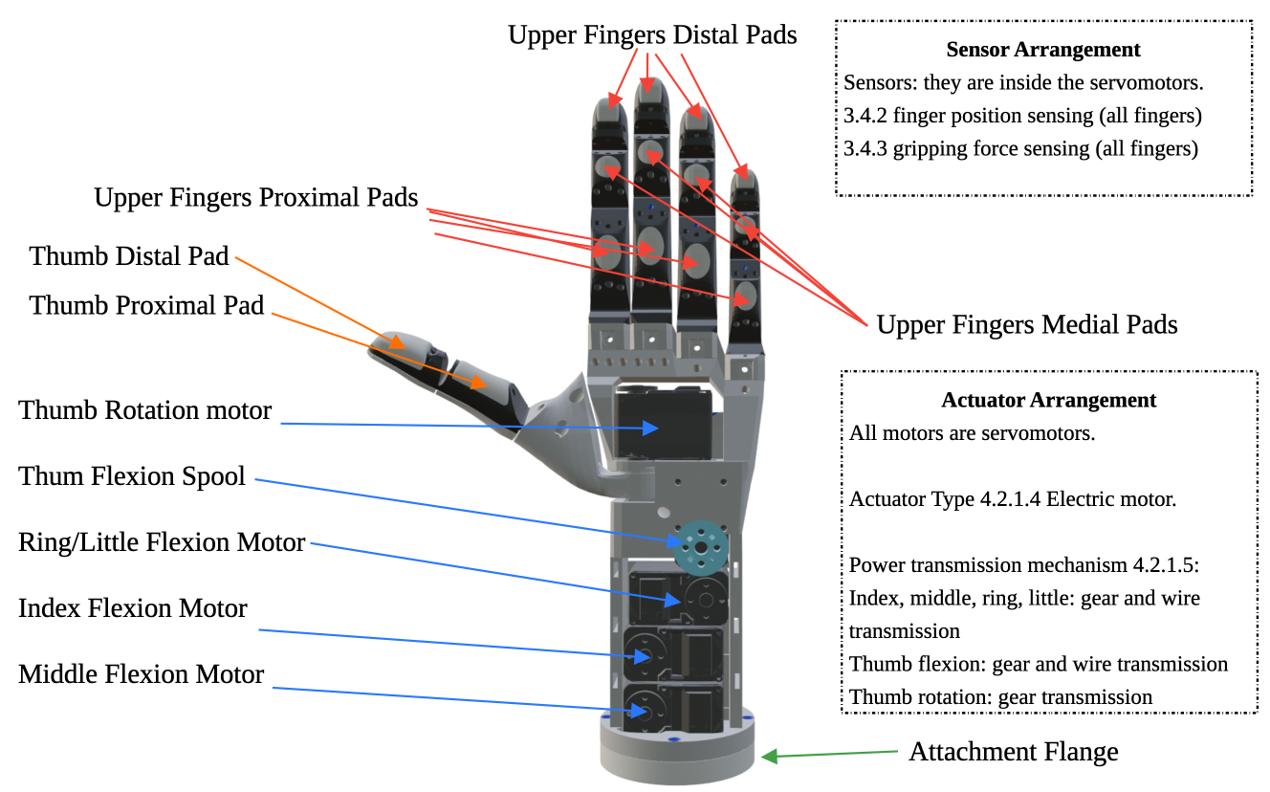Figure 17: Detailed drawing - left hand - internal view

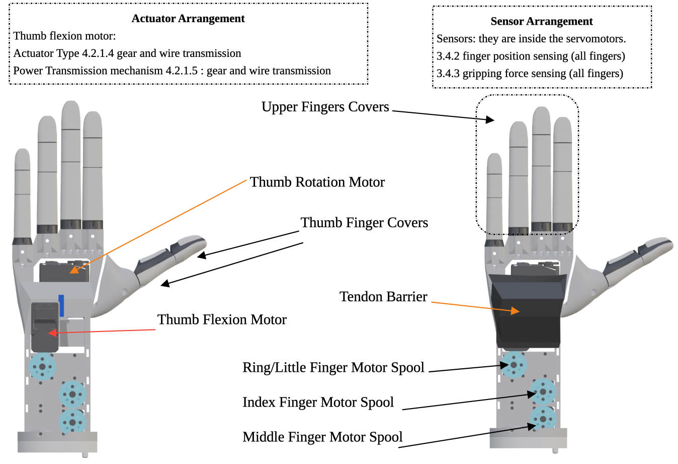Figure 18: Left Hand - Arrangement of actuators and sensors

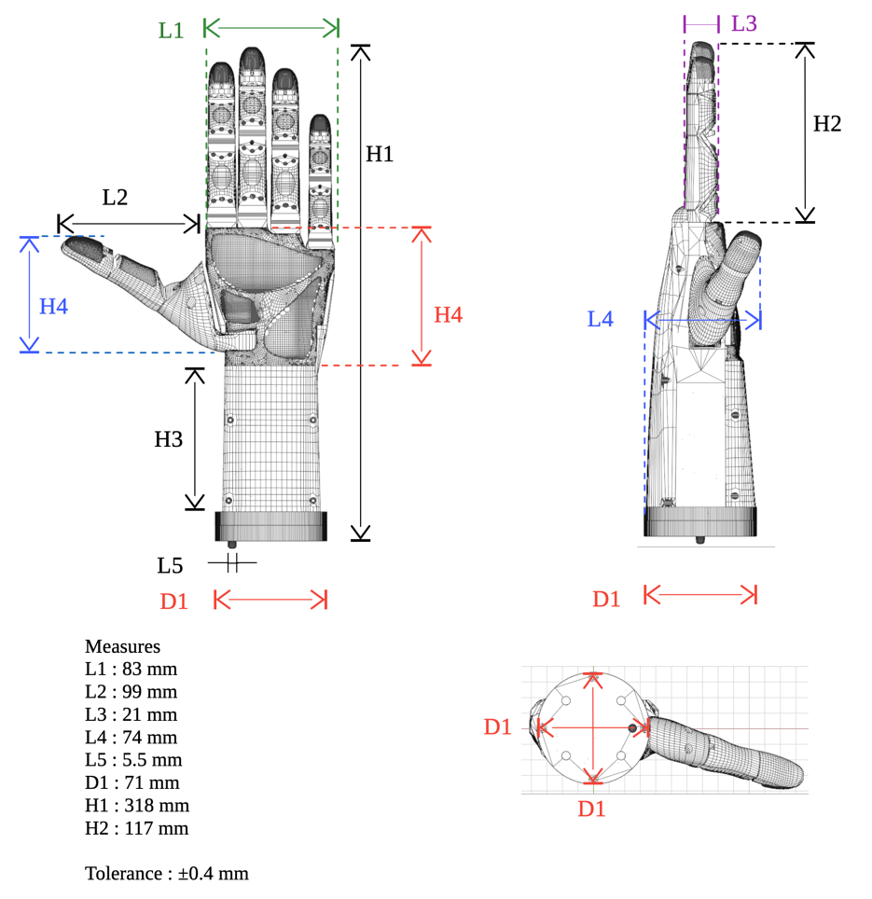Figure 19: Left Hand Measures
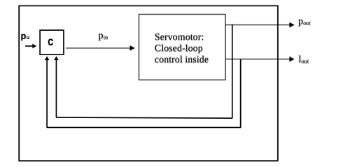

p_{u} : user desired position
p_{in} : C controller commanded position
p_{out} : real output position
l_{out} : real output load
C : Gripper main controller
Drawing 1: Block Diagram - Finger Flexion/Extension Control System

Components
Components:
- skeleton
- fingers
  - index with silicon pads
  - meddle with silicon pads
  - ring with silicon pads con
  - little with silicon pads con
  - Thumb with silicon pads
- servomotors and cables
- logic card
- tendon winding coils
- polyethylene tendons
- nuts and bolts
  - bolts M3 with countersunk head
    - long 20mm
    - long 15mm
    - long 10mm
  - bolts M3 with hexagonal head
    - long 10mm
  - bolts M6
    - long 3.5cm
  - broken washers M3
  - self-tapping screws M2
    - long 8mm
    - long 10mm
- tendons-barrier
- thumb base
- nylon cable ties
- hand palm with silicon pads
- covers
  - front cover
  - rear cover
  - mechanical connection flanges
    - Flange for robot manipulator UR3 (for the final joint on the wrist)

Nomenclature parts

Note: the holes are indicated in RED

Nomenclature servomotors holes thumb

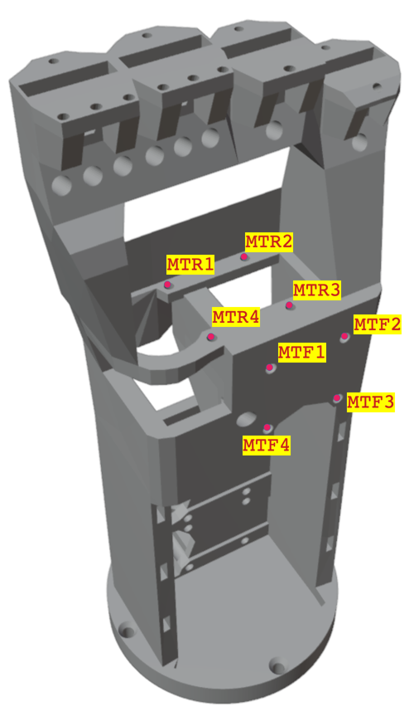Figure 20: Left Hand Skeleton - Front View – servomotors holes

Nomenclature servomotors holes upper fingers

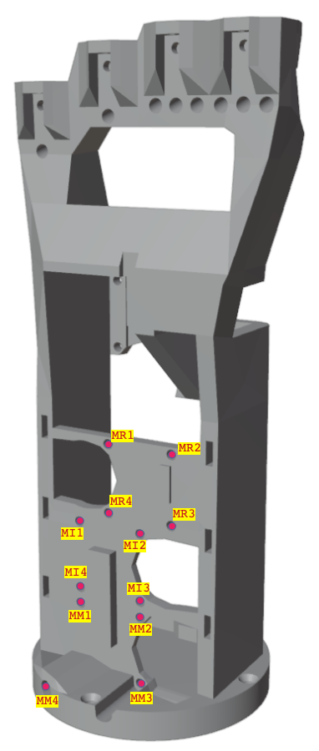Figure 21: Left Hand Skeleton- rear view - servomotors holes

Nomenclature servomotors slot
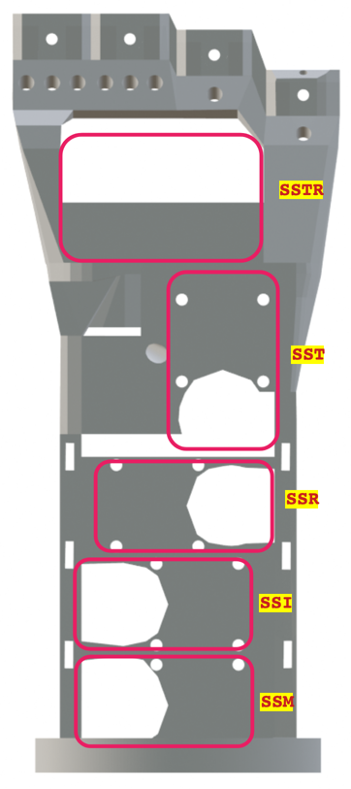Figure 22: Left Hand Skeleton - front view - slot servomotors

Nomenclature servomotors holes flange
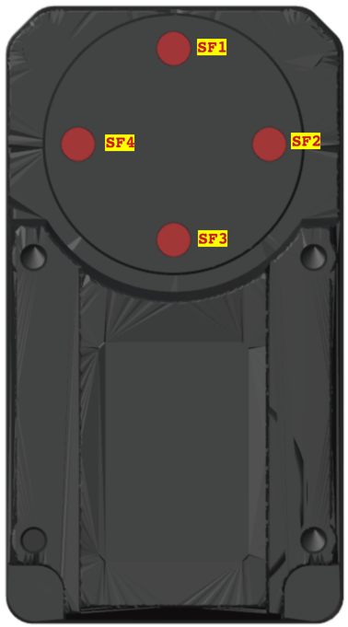Figure 23: Servomotors Waveshare ST3215 ST3215/HS - holes

Nomenclature Tendons-Barrier holes

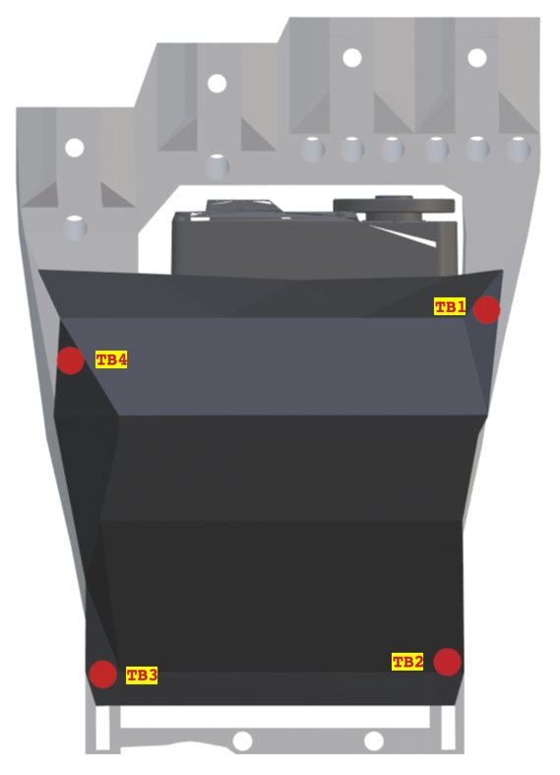Figure 24: Left Hand - Front View – tendons barrier holes

Nomenclature slot and holes upper fingers

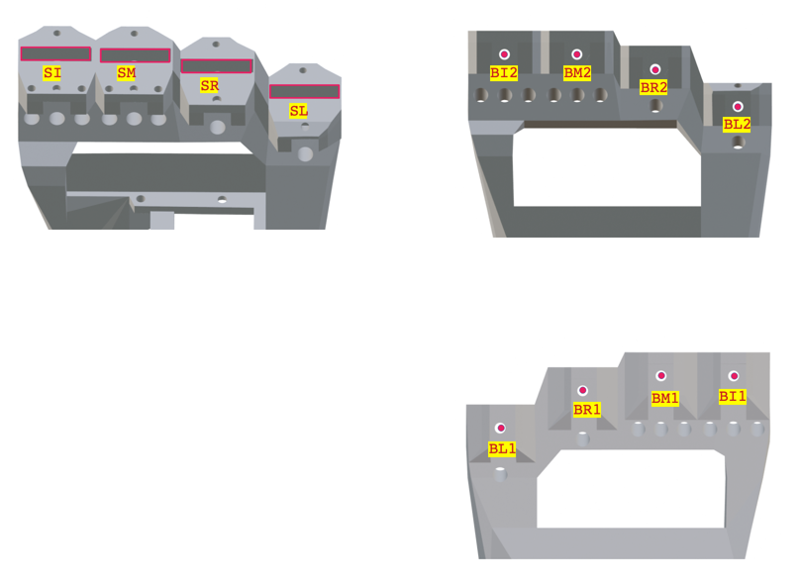Figure 25: Left Hand - Skeleton – Front View – holes and slot upper fingers

Nomenclature slot and holes Thumb base

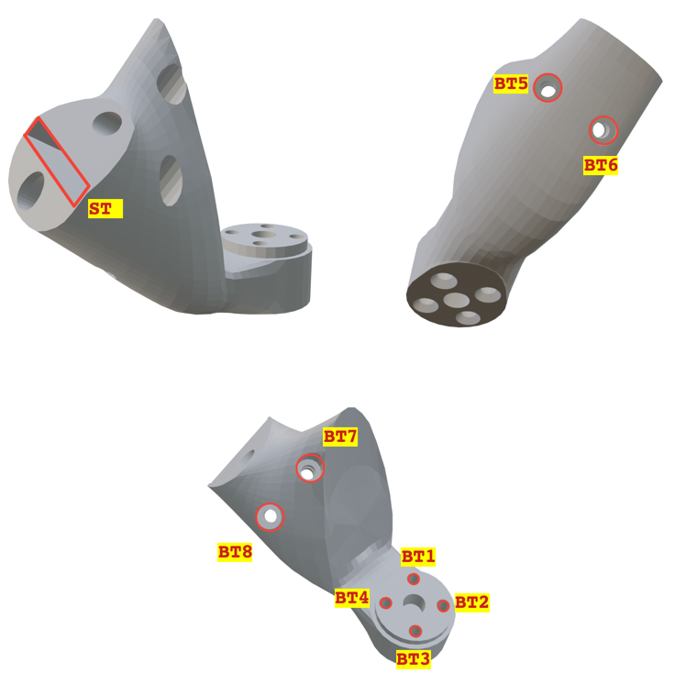Figure 26: Left Hand - Front View - holes and slot thumb base

Nomenclature tendons holes
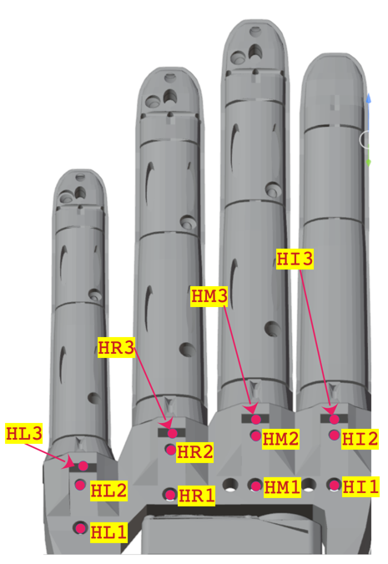Figure 28: Left Hand - Rear View - tendons holes
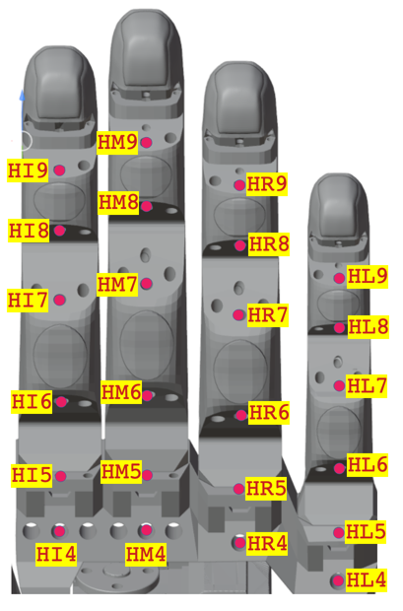Figure 27: Left Hand - Front View - tendons holes
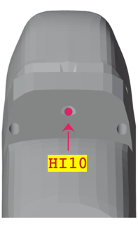Figure 29: Index Finger – Tendon Hole distal – view from below
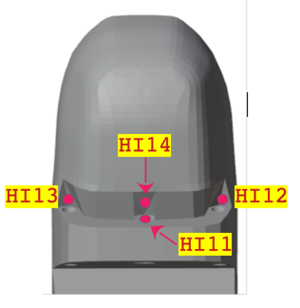Figure 30: Index Finger – Tendon Hole distal – view from above

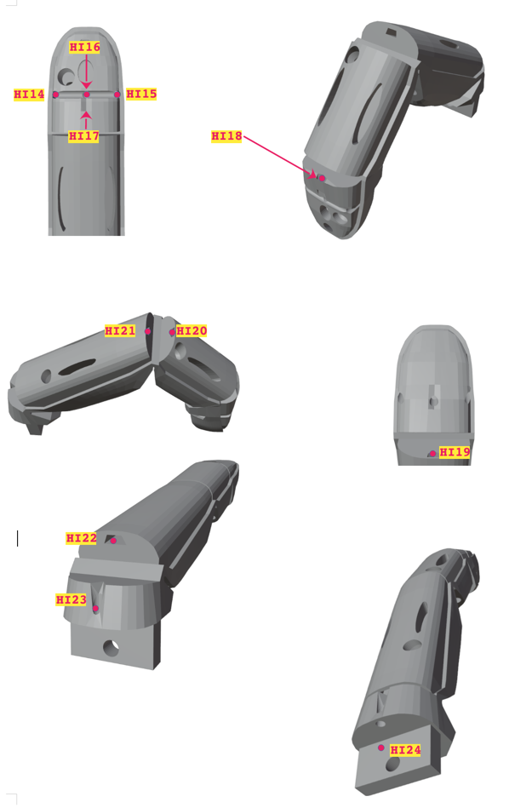Figure 31: Tendons holes index finger

Only the names of the holes for the index finger are shown. The names of the other finger holes can be obtained by replacing the prefix HI with the name of the desired finger. Below are the prefixes for the names of the other upper fingers (middle, ring, and little fingers).
- Middle: HM
- Ring: HR
- Little: HL

Nomenclature tendons holes thumb
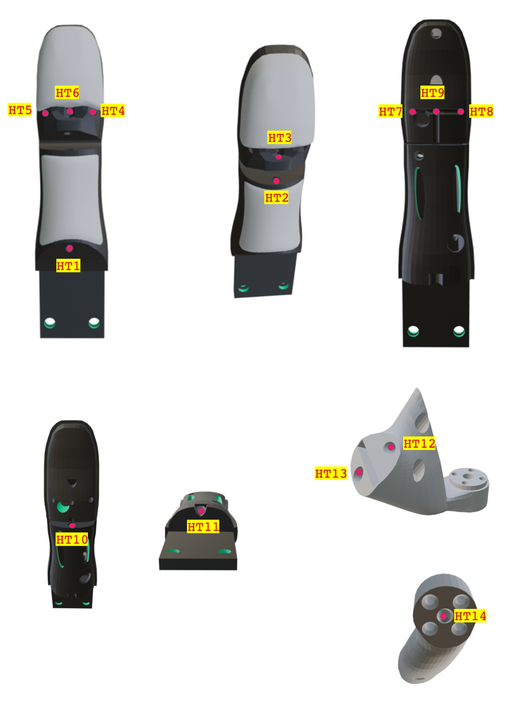Figure 32: Thumb tendons holes

Nomenclature spools holes

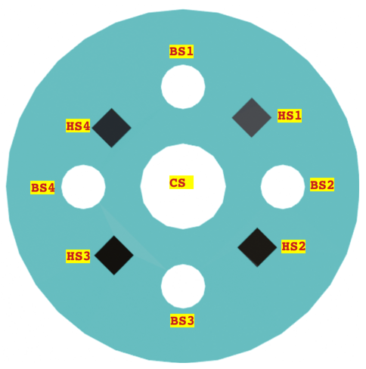Figure 33: spools holes

Nomenclature hand palm holes
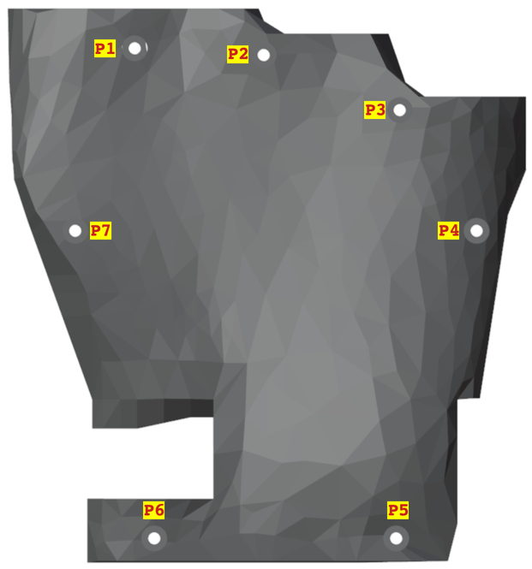Figure 34: left hand – hand palm holes

Nomenclature covers
TBD: Prepare skeleton joints in CAD, document with photos

Nomenclature electronic board holes
TBD: Prepare board slots and holes in CAD, document with photos

